IBM DB2 on Cloud

Create an instance of IBM DB2 on Cloud

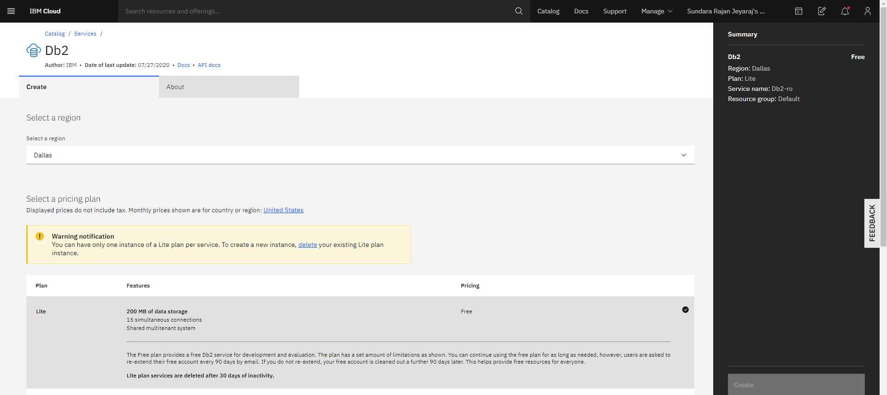

Reference doc: <https://cloud.ibm.com/docs/Db2onCloud?topic=Db2onCloud-getting-started>

Our Db2 instance (Db2-hq)

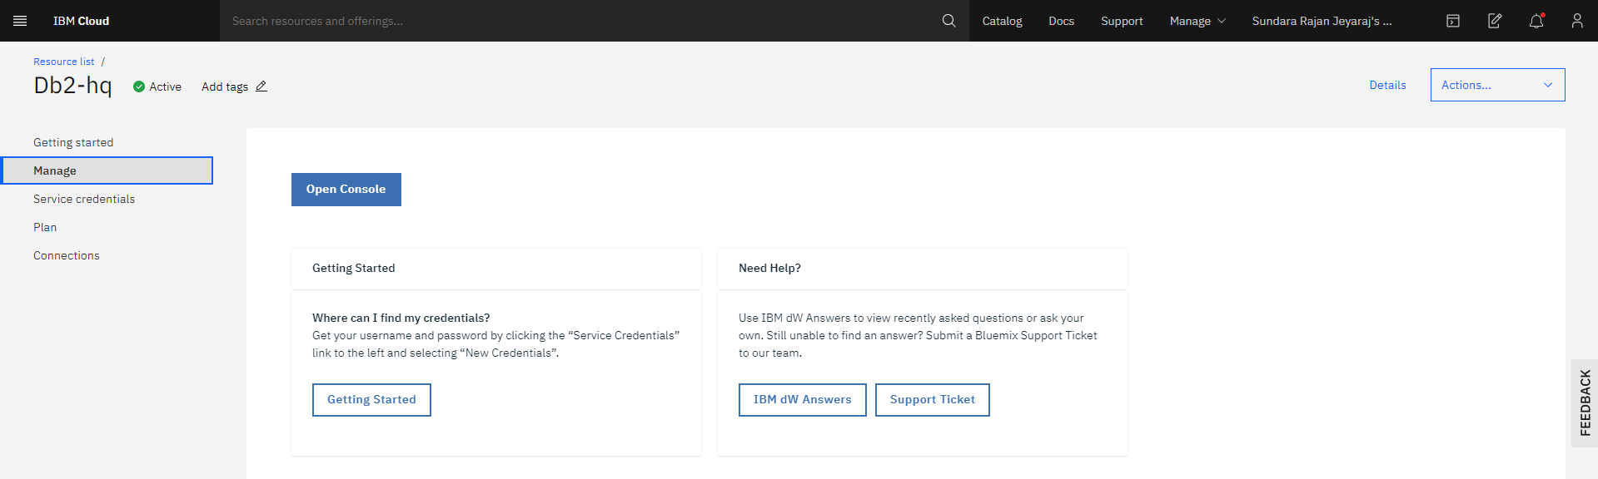

In Db2 Console

Create below two tables

1. SOIL_MOISTURE_LOG
2. CROP_DATA

Rquired SQL querries

1. 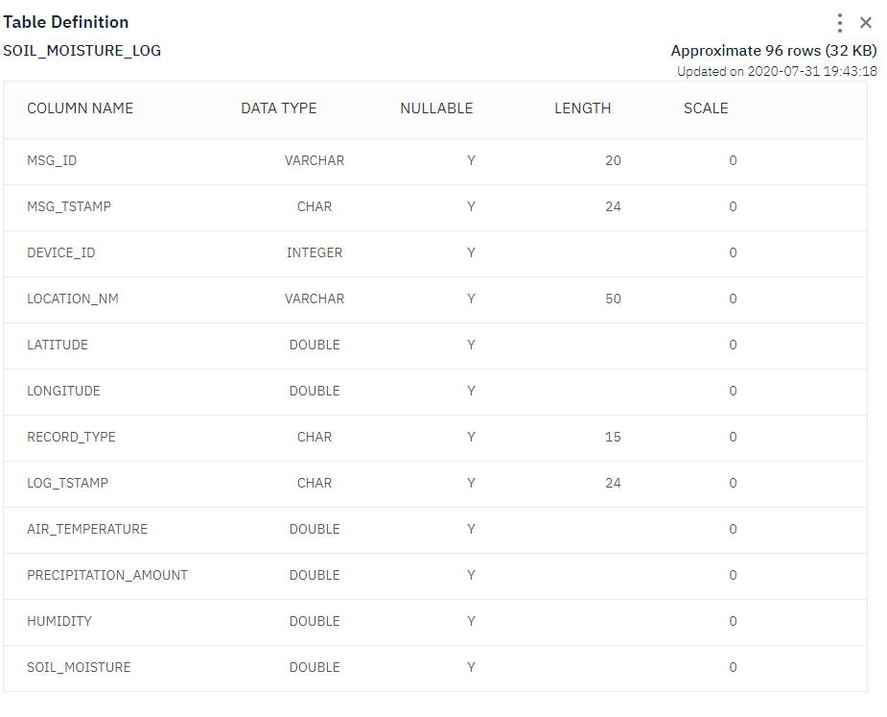Create SOIL_MOISTURE_LOG table

CREATE TABLE "RFC61298"."SOIL_MOISTURE_LOG"

( MSG_ID VARCHAR(20) ,

MSG_TSTAMP CHAR(24) ,

DEVICE_ID INTEGER,

LOCATION_NM VARCHAR(50) ,

LATITUDE DOUBLE ,

LONGITUDE DOUBLE ,

RECORD_TYPE CHAR(15) ,

LOG_TSTAMP CHAR(24) ,

AIR_TEMPERATURE DOUBLE ,

PRECIPITATION_AMOUNT DOUBLE,

HUMIDITY DOUBLE ,

SOIL_MOISTURE DOUBLE )

1. Create CROP_DATA table

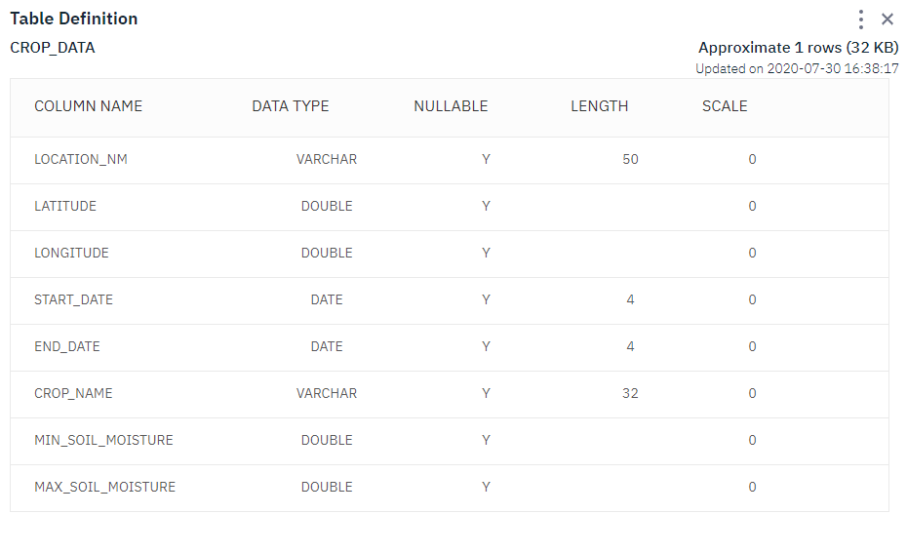

CREATE TABLE "RFC61298"."SOIL_MOISTURE_LOG"

( LOCATION_NM VARCHAR(50) ,

LATITUDE DOUBLE ,

LONGITUDE DOUBLE ,

START_DATE DATE ,

END_DATE DATE ,

CROP_NAME VARCHAR(32) ,

MIN_SOIL_MOISTURE DOUBLE ,

MAX_SOIL_MOISTURE DOUBLE )

Note: Replace the schema name of your DB2 instance

Snap of querries saved in script library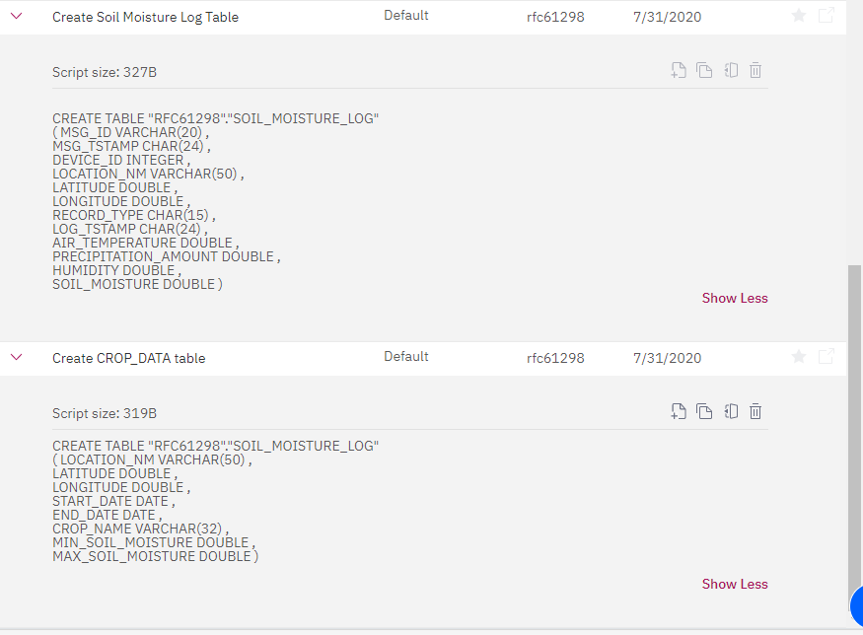



Service Credentials of DB2 instance

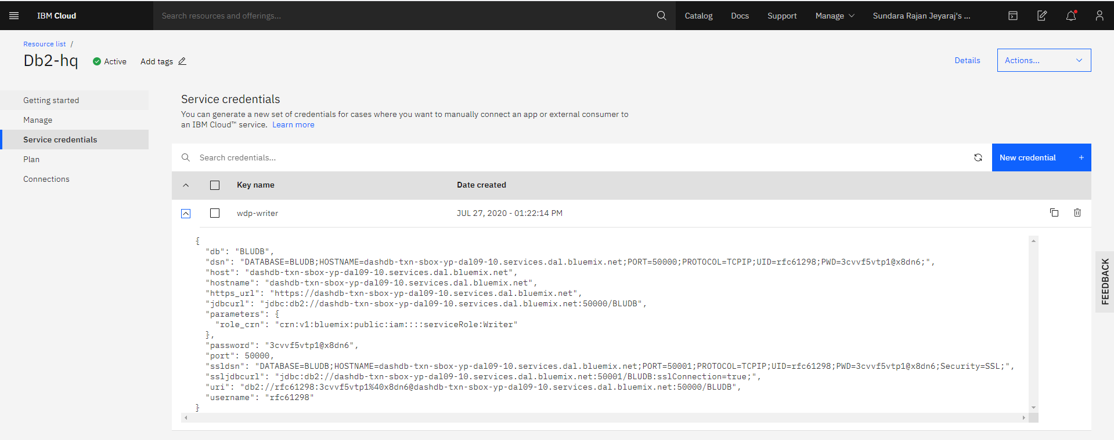

Db2 connection to Node Red App which is installed in Cloud Foundry

